Monday 16th January 2023

**OfSTED INSPECTION 2022**

Dear Parent/Carer,   
   
On behalf of myself, Mrs Rudd and all the staff and governors, it gives us great pleasure to circulate the official report for Saint Mary’s Catholic Voluntary Academy, Glossop.

We are a **GOOD** school and we are delighted to be able to share this news with you. We can all be very proud of and it gives us a solid basis from which to move forward from and strive to become even better.

We are thrilled for the staff and students at Saint Mary’s and this judgement is well deserved. The success of our school is down to a real team effort being in place and the findings are testament to that. The staff and Local Governing Body work incredibly hard and are fully committed to giving the best of themselves for your children. We are so very grateful to them all and it was wonderful to hear the inspectors feedback throughout the process about all the good things they were seeing and hearing. Typically, they talked of passionate teachers and leaders who have put together an inclusive and ambitious curriculum; of lessons linking beautifully together and building on knowledge; to a Local Governing Body that care deeply and know the school well.

Equally, we are very proud of all our pupils and it was lovely to hear the inspectors talk about the children in such glowing terms. The lead inspector commented on the high standards of behaviour they displayed, their eloquence in the answers they gave and the tenacity and resilience they showed when completing challenging pieces of work. Reference was also made to how much they enjoy school, how they feel safe and enjoy all the extra-curricular opportunities on offer. From the youngest to the oldest pupils, they shone and the inspection team were very impressed by them.

Thank you to all the parents and carers who took the time to complete the OfSTED survey and to speak to the inspection team at the start of the day. Your ongoing support is very much valued and we are continually looking for ways to engage with you to ensure that each and every child at Saint Mary’s is given the best possible start to their education journey.

There are lots of positives that can be taken from the report and this is down to all the hard work that has taken place over the past few years. It has been a period of rapid growth and this has been pivotal to enabling our school to be where it is now. We also know that we can improve further and this is something that we will embrace and rise to the challenge of.

Here’s to the next chapter…

Yours Sincerely,

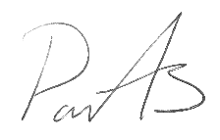 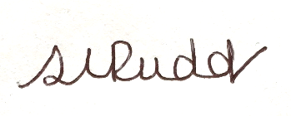

Mr Paul Ackers and Mrs Sarah Rudd